In this video we will discuss **Logon triggers in SQL Server**.   
  
   
  
As the name implies **Logon triggers fire in response to a LOGON event**. Logon triggers fire after the authentication phase of logging in finishes, but before the user session is actually established.    
  
**Logon triggers can be used for**  
1. Tracking login activity  
2. Restricting logins to SQL Server  
3. Limiting the number of sessions for a specific login   
  
**Logon trigger example :** The following trigger limits the maximum number of open connections for a user to 3. 

CREATE TRIGGER tr_LogonAuditTriggers

ON ALL SERVER

FOR LOGON

AS

BEGIN

    DECLARE @LoginName NVARCHAR(100)

    Set @LoginName = ORIGINAL_LOGIN()

    IF (SELECT COUNT(*) FROM sys.dm_exec_sessions

         WHERE is_user_process = 1

         AND original_login_name = @LoginName) > 3

    BEGIN

         Print 'Fourth connection of ' + @LoginName + ' blocked'

         ROLLBACK

    END

END

**An attempt to make a fourth connection, will be blocked.**   
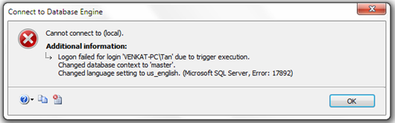   
  
The trigger error message will be written to the error log. Execute the following command to read the error log.  
Execute sp_readerrorlog   
  
